**9.5 Testing WiFi Connection and performance**

### **9.6 Objective**

* To successfully establish a stable Wi-Fi connection by configuring and placing Wi-Fi credentials into the Arduino WiFi R4 code and verifying reliable network performance.

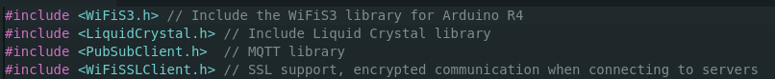

Figure 10

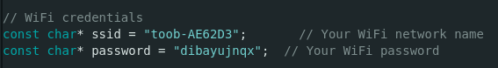

Figure 11

Picture

Figure 12

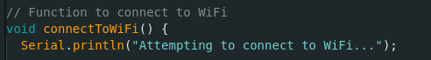

Figure 13

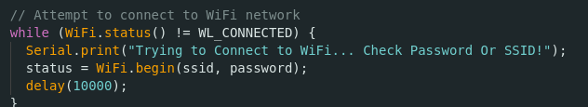

Figure 14

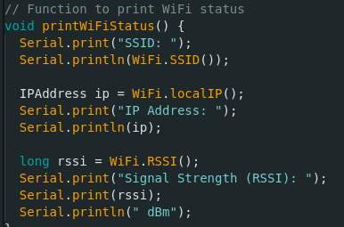

Figure 15

### **9.7 Approach**

* Insert correct SSID and password into the Arduino source code.
* Initiate a Wi-Fi connection upon device startup.
* Monitor connection status using Serial Monitor outputs.
* Test for reconnection behaviour if the connection drops.

Screenshot of serial monitor

## **9.8 Bug Fixes and Improvements**

### **9.9 Initial Setup**

Adding the network credentials and connection commands first allowed the Arduino R4 WiFi to successfully communicate with the ESP32-S3, enabling a stable connection to my home network. Building the main program logic around a confirmed network connection prevented previous errors encountered when attempting to embed Wi-Fi functionality into the existing codebase.